**Course Description/Goals:**

Welcome to Advanced Placement United States History. This course will challenge students’ academic abilities, develop students’ historical knowledge, understanding and thinking, while also preparing students for high levels of achievement on the College Board Advanced Placement Exam in United States History. Students who successfully complete this course and pass the Advanced Placement Exam in United States History will earn college credit. This year long weighted course meets graduation requirements for 11th grade United States History.

Students will study the history of the United States and address Political, Economic, Religious, Social, Intelligence, and Cultural aspects of each major period from the Pre-Columbian period to the present.

**Course Objectives:**

1. To understand the discipline of history and the process a historian uses to reconstruct the past.
2. The course teaches students to analyze evidence and interpretations presented in historical scholarship (Historiography)
3. Understand the political, economic, cultural, and social forces that have shaped the people of the United States from the early Eighteenth Century to the present day.
4. To use primary documents in the study of major themes of American History from the founding of the original colonies to the present time.
5. To prepare for the AP Exam in US History.
6. To reinforce skills necessary for student success in university studies and as an active and informed citizen of the United States.

**Student Expectations**:

Advance Placement United States History is the academically highest-level Social Studies course offered to high school students. This course has the potential to provide college credit for students successful in passing the AP Exam. Therefore, AP US History students have very specific expectations both academically and behaviorally. AP US History students are expected to:

* **Read assigned text and supplement materials** (Reading is an integral part of this course, students must be disciplined and prepared for extensive reading and note-taking in order to be prepared for the AP Exam)
* **Turn in all assignments on time** (late work is either not allowed or will result in drastic reduction in points)
* Think about what you are reading and learning.
* Participate as both team members and leaders, in discussions, activities.
* Communicate effectively (orally and in writing)
* Be responsible and self-directed learners.
* Ask questions.
* Be courteous and always use good conduct.

***All students are expected, but are not required to, take the Advance Placement Exam.***

**Books**

*Primary Texts*

* + - 1. The American YAWP, Stanford University Press.
      2. OpenStax US History Open Textbook, Rice University Press.

*Supplement Texts will assist students with difficult content.*

* AMSCO Publishing, United States History- Preparing for the Advanced Placement Examination <http://www.amscopub.com/social-studies-ap> (Highly Recommended)

**Web Resources:**

Students should access the following web sites to support their work at in AP US History.

* AP Classroom (This will be utilized on a regular basis.)
* US History Support <http://www.course-notes.org/us_history/>
* AP US History Test Prep <http://www.mrburnett.net/APUSHistory/APUSHistory.htm>

**Grading**/**Assessment/Methods/Strategies**:

Grades will be calculated based on student mastery of content and skills as measured by tests, quizzes, essays, homework, discussions, in class participation and projects. A traditional ten percent scale will be used to calculate letter grades:

A = 100-90 %, B 89-80, C = 79-70, D = 69-60, F= 59%.

Each assignment will be given a point value and added to your quarterly point total. Test are worth 100 points with the points being added to your total. At the end of each grading period your point totals are used to calculate your grade, for example, if you have earned 100-90% of the points possible for the grading period then your grade is an “A”

**Reading:**

Our textbook is *The American YAWP*. Students will be given daily reading assignments from our American YAWP textbook. In addition to the daily reading there will be a journal entry requirement for each reading assignment and will be due before the start of the next school day and will not be accepted late for any other reason than legitimate cleared absence. In addition, we will be reading many primary source materials, which I will provide to students as the school year unfolds and are also available for download on Schoology.

**Writing & Document Analysis:**

The central focus of APUSH is helping students to improve their historical writing skills. Specifically, students will learn how to respond to the Free-Response Questions (FRQs) and Document Based Question (DBQ) sections of the AP Exam. Students will be required to complete take-home and in-class essays. Entire class periods are devoted to the return of graded essays, discussion of the most common positive and negative aspects of each set, and the distribution of examples of well-written essays.

**Assessments:**

Each unit will conclude with two assessments. The first assessment will be a standard multiple-choice test. The second will be DBQs and FRQs.

***Classroom Policies***

**Make Up Work and Attendance:**

Assignments and points will be given each day.

Students who are absent from class will be expected to check the website from home or contact a classmate, stay up to date on their studies, and be prepared to return to class with all assignments completed on time. If you have problems accessing the internet outside of school, please let me know and we will make other arrangements to support your studies while you are out of school.

If a student is absent when a homework assignment is due, they must turn in the assignment the next day they attend school.

The attendance office must clear all absences, or no credit or makeup will be allowed.

Truancies will result in loss of grade points, lowered citizenship, and possible detention.

**Tardy Policy:**

Tardy is defined in our class as not being in your seat ready to learn for the day. You will be considered tardy if you are not in your seat and prepared for class. If students must come late to class, they should not talk to the teacher or interrupt the class when they come in. Students should sign the tardy sign in sheet, sit down, and begin work and I will speak with students at the end of class. Tardies 1-4 will receive documentation along with parent contact. After your 4th tardy, you will receive an administrative referral. We want you in our class!! YOU HAVE PURPOSE. We will support you in this.

**Seating Charts** will be used. All students will sit in assigned seats.

**Supplies Needed**: Binders/notebooks, paper, pencils, pens, highlighters, **charged laptop**.

**Academic Honesty:**

Thank you for always doing your own work and trying your best.

The school policy on Academic Honesty will be followed. You will earn a zero for any assignment that you are found cheating on, along with parent contact. (Please see school handbook concerning our policy on Academic Honesty)

# This syllabus can be amended at the discretion of the instructor.

**Course Content:**

Historical Thinking Skills are a key element to APUSH:

“The AP US History course seeks to apprentice students to the practice of history by explicitly stressing the development of historical thinking skills while learning about the past.”

Students will be trained to think like a historian using these skills and approaches.

**APUSH Thinking Skills:**

* **Analysis:** Evaluate the P.O.V., purpose, audience, significance and reliability of a source.
* **Interpretation:** Understand and assess varying opinions on the meaning of evidence or events.
* Comparison: Evaluate similarities and differences within or across geography and chronology.
* **Periodization:** Understand and evaluate why history is divided into distinct eras with definite start and end dates.
* **Contextualization:** Connect events and processes to broader circumstances; situate events within the “bigger picture.”
* **Causation:** Explain and evaluate long and short term factors – both predictable and unexpected - which lead to events occurring.
* **Continuity & Change:** Identify and evaluate consistent patterns as well as alterations to those patterns over time.
* **Argumentation:** Articulate a compelling thesis and support it with multiple kinds of evidence while acknowledging contradictory perspectives.
* **Synthesis:** Make connections between various contexts, periods, themes and disciplines.

**General Historical Themes:**

1. **American Diversity:** The diversity of the American people and the relationships among different groups. The roles of race, class, ethnicity, and gender in the history of the United States.
2. **American Identity:** Views of the American national character and ideas about American exceptionalism. Recognizing regional differences within the context of what it means to be an American.
3. **Culture:** Diverse individual and collective expressions through literature, art, philosophy, music, theater, and film throughout U.S. history. Popular culture and the dimensions of cultural conflict within American society.
4. **Demographic Changes:** Changes in birth, marriage, and death rates; life expectancy and family patterns; population size and density. The economic, social, and political effects of immigration, internal migration, and migration networks.
5. **Economic Transformations:** Changes in trade, commerce, and technology across time. The effects of capitalist development, labor and unions, and consumerism.
6. **Environment:** Ideas about the consumption and conservation of natural resources. The impact of population growth, industrialization, pollution, and urban and suburban expansion.
7. **Globalization:** Engagement with the rest of the world from the fifteenth century to the present: colonialism, mercantilism, global hegemony, development of markets, imperialism, and cultural exchange.
8. **Politics and Citizenship:** Colonial and revolutionary legacies, American political traditions, growth of democracy, and the development of the modern state. Defining citizenship; struggles for civil rights.
9. **Reform:** Diverse movements focusing on a broad range of issues, including anti-slavery, education, labor, temperance, women’s rights, civil rights, gay rights, war, public health, and government.
10. **Religion:** The variety of religious beliefs and practices in America from prehistory to the twenty-first century; influence of religion on politics, economics, and society.
11. **Slavery and Its Legacies in North America:** Systems of slave labor and other forms of unfree labor (e.g., indentured servitude, contract labor) in American Indian societies, the Atlantic World, and the American South and West. The economics of slavery and its racial dimensions. Patterns of resistance and the long-term economic, political, and social effects of slavery.
12. **War and Diplomacy:** Armed conflict from the precolonial period to the twenty-first century; impact of war on American foreign policy and on politics, economy, and society.

Access the College Board Outline to review detailed course content:

**College Board Advance Placement Information** <http://www.collegeboard.com/student/testing/ap/history_us/topics_1_9.html?ushist>

**Course Theme: The “Empire of Liberty”**

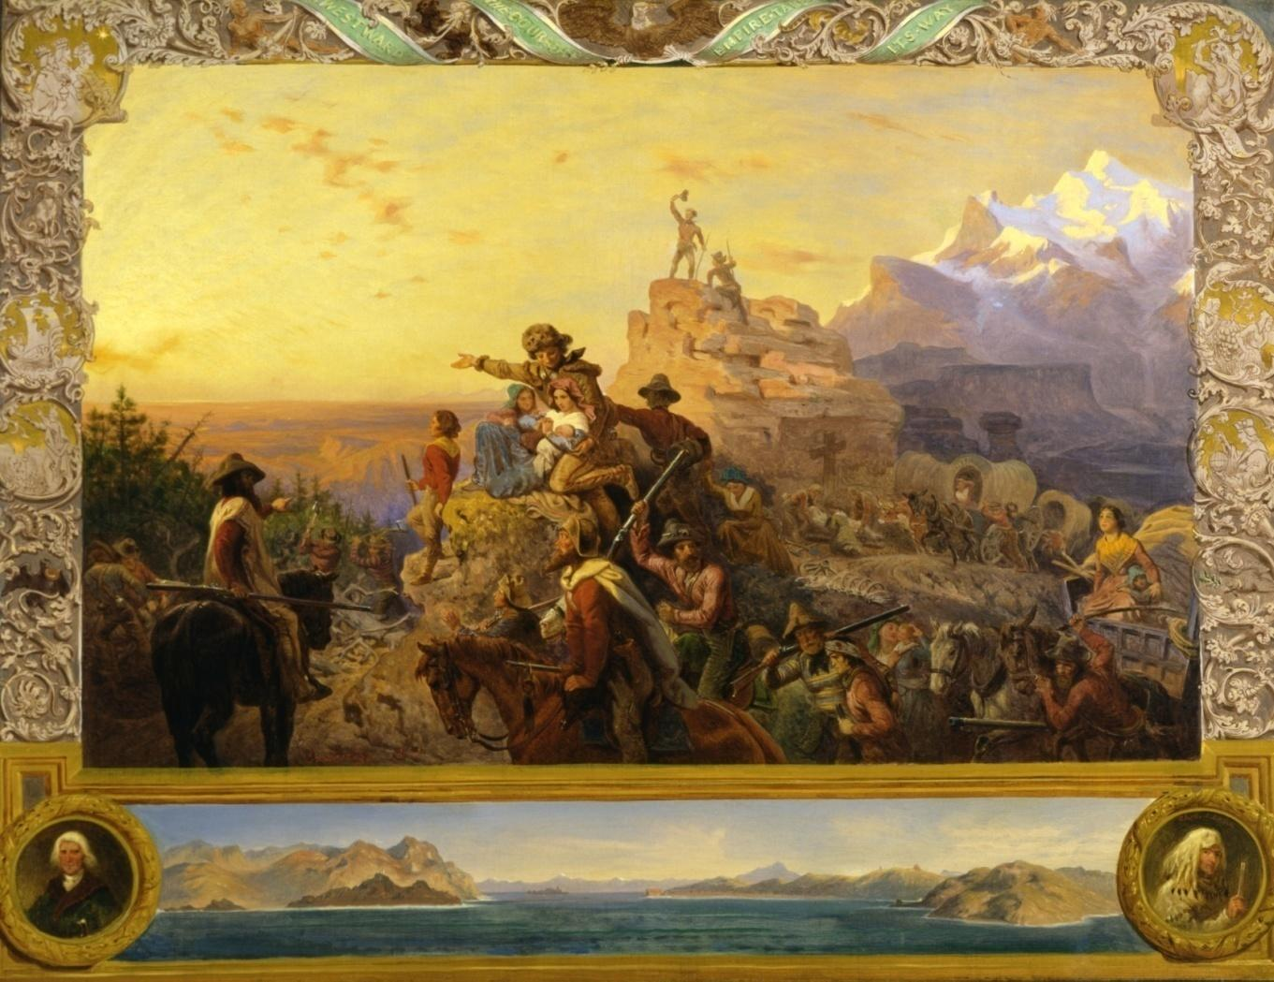

Thomas Jefferson described the United States as an “Empire of Liberty.” He believed that the young nation was destined to spread its influence far beyond the original 13 colonies, and with that growth would spread the ideals of equality, freedom, and economic opportunity for all.

We will revisit Jefferson’s concept of the “Empire of Liberty” throughout the year, considering the following questions along the way:

* How has the U.S. expanded its geographic boundaries?
* How has the U.S. spread its political, economic and cultural influence beyond its own borders?
* In what ways do the concepts of “empire” and “liberty” go hand-in-hand? In what ways are the concepts contradictory?
* How does the concept of the “Empire of Liberty” apply to [insert name of unit currently being studied]?
* Has American influence been a blessing or a curse for the peoples in lands we have touched?
* Is the United States truly “exceptional” among the nations of the world?
* What can learn from our past to guide the future of the “Empire of Liberty”?

**Course Calendar**

|  |  |
| --- | --- |
| **Unit 1/Period 1: 1491-1607** | |
| **Themes** | Course Introduction  Syllabus  How to Study History  Native Americans in Pre-Columbian North America  Early Colonization of the New World  Competition for Global Dominance |
| **Calendar dates (approximate)** | August 8-August 23 |
| **The American YAWP** | **Chapter 1: Indigenous America**  **Chapter 2:**  **Colliding Cultures** |
| **Additional Texts & Primary Sources** | Annotate documents and use the Annotate documents and use the HIPPO analysis  H—Historical Context  I—Intended Audience  P—Point of View  P—Purpose  O—Outside Information analysis tool (speaker, occasion, audience, purpose, subject, tone)  Samuel Eliot Morison, *Admiral of the Ocean, A Life of Christopher Columbus*   * Justin Winsor, *Christopher Columbus And How He Received And Imparted The Spirit Of Discovery* * Christopher Columbus Letter to King Ferdinand Of Spain, 1493 * Daniel Boorstin, *A Historian’s Interpretation of Columbus’ First Journey* * An Account of An American Ceremony * From Bartolomé de las Casas Brief Account of the Devastation of the Indies (1542) * Richard Hakluyt, an Argument for Colonization from *Discourse Concerning Western Planting* (1584) |
| **Historical Scholarship** | Hugh Thomas – *Conquest: Montezuma, Cortes, and the Fall of Old Mexico* (excerpt) |
| **Writing Assignment** | **DBQ 1993: New England vs. Chesapeake Colonies**  “Although New England and the Chesapeake region were both settled largely by people of English origin, by 1700 the regions had evolved into two distinct societies. Why did this difference in development occur? Use the documents and your knowledge of the colonial period up to 1700 to develop your answer.”  (ID-4, ID-5, PEO-1, PEO-4, PEO-5, POL-1, WXT-1, WOR-1, ENV-2, ENV-4)  APUSH THEME: ENVIRONMENT & GEOGRAPHY (ENV) |
| **Assessment(s)** | Multiple Choice Test |

|  |  |
| --- | --- |
| **Unit 2/Period 2: 1607-1754** | |
| **Themes** | The English Arrive  French Colonization of North America  The Pilgrims and the Massachusetts Bay Company  Other Early Colonies  Slavery in the Early Colonies  The Age of Salutary Neglect  Life in the Colonies |
| **Calendar dates (approximate)** | August 26-September 12 |
| **The American YAWPtextbook reference** | **Chapter 3** – British North America  **Chapter 4**– Colonial Society |
| **Primary Sources** | Annotate documents and use the HIPPO  H—Historical Context  I—Intended Audience  P—Point of View  P—Purpose  O—Outside Information analysis tool (speaker, occasion, audience, purpose, subject, tone)   * Maps of French & Indian War & Revolutionary War * British national debt graph/timeline * Colonial exports graph/timeline * Benjamin Franklin – 13 Virtues * Thomas Jefferson – Declaration of Independence |
| **Historical Scholarship** | Gordon S. Wood *– The Radicalism of the American Revolution* |
| **Writing Assignment** | **FRQ: Choose *one* of the following**   * “The history of the present King of Great Britain is a history of repeated injuries and usurpation, all having, in direct object, the establishment of an absolute tyranny over the states.” Evaluate this accusation against King George III in the Declaration of Independence. * “American victory in the war for independence was inevitable.” Assess the validity of this statement. * To what degree did the American Revolution bring about social, political and economic change in the former colonies?   (ID-5, POL-1, WOR-2, CUL-2, CUL-4, CUL5)  APUSH THEME: IDEAS, BELIEFS & CULTURE (CUL) |
| **Assessment(s)** | Multiple Choice Test |

|  |  |
| --- | --- |
| **Unit 3/Period 3: 1754-1800** | |
| **Themes** | The Struggle for the Continent  The New Imperialism  Stirrings of Revolt  Cooperation and War  The States United  The War for Independence  War and Society  The Creation of the State Governments  The Search for a National Government  Framing a New Government  Federalists and Republicans  Establishing National Sovereignty  The Downfall of the Federalists |
| **Calendar dates (approximate)** | September 15-October 21 |
| **The American YAWPtextbook reference** | **Chapter 5** – The American Revolution  **Chapter 6** – The New Nation  **Chapter 7** – The Early Republic |
| **Primary Sources** | Annotate documents and use the HIPPO  H—Historical Context  I—Intended Audience  P—Point of View  P—Purpose  O—Outside Information analysis tool (speaker, occasion, audience, purpose, subject, tone)   * Articles of Confederation Constitution of the United States * *Federalist #10* * *Federalist #13* * *Federalist #51* * *Antifederalist #10* * *Antifederalist #16* * *Antifederalist #17* * Ratification vote map & pie charts for each state * Map of electoral college and Congressional apportion by state |
| **Historical Scholarship** | Jeffrey Rogers Hummel – “The Constitution as Counterrevolution”  HISTORICAL SCHOLARSHIP DISCUSSION   * “To what extent was the Constitution a drastic, conservative departure from the Articles of Confederation?” * Cite evidence from the texts by Hummel (above) and Wood (from Unit 2) |
| **Writing Assignment** | Timed writing (35 minutes) FRQ: “To what extent was the Constitution a drastic, conservative departure from the Articles of Confederation?”  (CUL-2, CUL-4, POL-5)  APUSH THEMATIC LEARNING OBJECTIVE: POLITICS & POWER (POL) |
| **Assessment(s)** | Multiple Choice Test |

|  |  |
| --- | --- |
| **Unit 4/Period 4: 1800-1848** | |
| **Themes** | The Rise of Cultural Nationalism  Stirrings of Industrialism  Jefferson the President  Doubling the National Domain  Expansion and War  The War of 1812  Building a National Market  Expanding Westward  The “Era of Good Feelings”  Sectionalism and Nationalism  The Revival of Opposition  The Rise of Mass Politics  “Our Federal Union”  The Removal of the Indians  Jackson and the Bank War  The Changing Face of American Politics  The Changing American Population  Transportation, Communications, and Technology  Commerce and Industry  Men and Women at Work  Patterns of Industrial Society  The Agricultural North  The Cotton Economy  White Society in the South  Slavery: The “Peculiar Institution”  The Culture of Slavery  The Romantic Impulse  Remaking Society  The Crusade Against Slavery |
| **Calendar dates (approximate)** | October 22-November 15 |
| **The American YAWPtextbook reference** | **Chapter 7 –** The Early Republic (Second Half)  **Chapter 8**- Market Revolution  **Chapter 9**- Democracy in America  **Chapter 11**- The Cotton Revolution  **Chapter 12**- Manifest Destiny |
| **Primary Sources** | Annotate documents and use the HIPPO  H—Historical Context  I—Intended Audience  P—Point of View  P—Purpose  O—Outside Information analysis tool (speaker, occasion, audience, purpose, subject, tone)   * Electoral College results, 1789-1820 * Phyllis Wheatley – “Ode to George Washington” * George Washington – “Farewell Address” * Jefferson & Madison – “Virginia & Kentucky Resolutions” * Thomas Jefferson – “First Inaugural Address” * Francis Scott Key – “Star-Spangled Banner” * Edgar Allan Poe – “The Black Cat” * Henry David Thoreau – *Walden* (excerpt), “On Civil Disobedience” * James Fenimore Cooper – *The Last of the Mohicans* (excerpt) * Nathaniel Hawthorne – *The Scarlet Letter* (excerpt) * William Cullen Bryant – “Thanatopsis” * Advertisements for minstrel shows * Photographs of Neoclassical architecture * Paintings by Hudson River School artists, Gilbert Stuart and George Catlin * Audubon lithographs |
| **Historical Scholarship** | Gordon S. Wood –*Empire of Liberty* (excerpt) |
| **Writing Assignment** | **DBQ 1998: Jefferson & Madison**  “With respect to the federal Constitution, the Jeffersonian Republicans are usually characterized as strict constructionists who were opposed to the broad constructionism of the Federalists. To what extent was this characterization of the two parties accurate during the presidencies of Jefferson and Madison? In writing your answer, use the documents and your knowledge of the period 1801-1817.”  (ID-1, POL-2, POL-5, POL-6, CUL-2, CUL-5)  APUSH THEMATIC LEARNING OBJECTIVE: POLITICS & POWER (POL) |
| **Assessment(s)** | Multiple choice test  Speech: “The Common Good” |

|  |  |
| --- | --- |
| **Unit 5/Period 5: 1844-1877** | |
| **Themes** | “Empire of Liberty”  Economic Transformations  Politics and Citizenship  Reform  Religion  Slavery and Its Legacies in North America |
| **Calendar dates (approximate)** | November 18-December 13 |
| **The American YAWPtextbook reference** | * **Chapter 10-** Religion and Reform * **Chapter 1**3 – The Sectional Crisis * **Chapter 14** – The Civil War * **Chapter 15**- Reconstruction |
| **Primary Sources** | Annotate documents and use the HIPPO  H—Historical Context  I—Intended Audience  P—Point of View  P—Purpose  O—Outside Information analysis tool (speaker, occasion, audience, purpose, subject, tone)   * Electoral College results, 1824-1860 * Maps of westward expansion * Map of Indian Removal, the Trail of Tears and Oklahoma reservations * Political cartoons about Andrew Jackson * John L. O’Sullivan – “Manifest Destiny” * Southern population pie charts – racial composition of the south * Cotton production & export graphs * David Walker’s *Appeal* (excerpt) * Elizabeth Cady Stanton & Lucretia Mott – “Seneca Fall Declaration of Sentiments” * “Tall Tales” * South Carolina Declaration of Causes * Abraham Lincoln – “First Inaugural Address” |
| **Historical Scholarship** | Richard Hofstadter – *The American Political Tradition and the Men Who Made It* (excerpt)  HISTORICAL SCHOLARSHIP DISCUSSION:   * Compare and contrast the historical assessments of Thomas Jefferson and Andrew Jackson in terms of race and slavery, economics and westward expansion * Cite arguments and evidence from Hofstadter (above) and Wood (from Unit 4) |
| **Writing Assignment** | **DBQ 2006: American Women, 1770-1861**  Discuss the changing ideals of American womanhood between the American Revolution (1770s) and the Civil War. What factors fostered the emergence of “republican motherhood” and the “cult of domesticity”? Assess the extent to which these ideals influenced the lives of women during this period. In your answer, be sure to consider issues of race and class.”  (WXT-2, WXT-4, WXT-5, PEO-5, POL-3, POL-6, ENV-3, CUL-2, CUL-4, CUL-5)  APUSH THEMATIC LEARNING OBJECTIVE: WORK, EXCHANGE & TECHNOLOGY (WXT) |
| **Assessment(s)** | Multiple choice test |

|  |  |
| --- | --- |
| **Unit 6/Period 6: 1865-1898** | |
| **Themes** | “Empire of Liberty”  American Identity  Economic Transformations  Politics and Citizenship  Slavery and Its Legacies in North America  War and Diplomacy |
| **Calendar dates (approximate)** | January 9-February 4 |
| **The American YAWPtextbook reference** | **Chapter 16** – Capital and Labor  **Chapter 17** – The West  **Chapter 18** – Life in the Industrial Age |
| **Primary Sources** | Annotate documents and use the HIPPO  H—Historical Context  I—Intended Audience  P—Point of View  P—Purpose  O—Outside Information analysis tool (speaker, occasion, audience, purpose, subject, tone)   * Electoral College results, 1860-1876 * Maps of the Civil War & the South under Reconstruction * Political cartoons by Thomas Nast * Walt Whitman – “Beat! Beat! Drums!,” “O Captain, My Captain!” * Abraham Lincoln – “Letter to Mrs. Bixby,” “Gettysburg Address,” “Second Inaugural Address” * Civil War casualty figures |
| **Historical Scholarship** | Eric Foner – *Reconstruction* (excerpt) |
| **Writing Assignment** | **DBQ 2009: African Americans & the Civil War**  “In what ways did African Americans shape the course and consequences of the Civil War?”  (ID-2, ID-6, WXT-4, WXT-5, PEO-3, PEO-5, POL-2, POL-3, POL-6, WOR-2, ENV-3, CUL-2, CUL-5)  APUSH THEMATIC LEARNING OBJECTIVE: IDENTITY (ID) |
| **Assessment(s)** | Multiple choice test  Seminar discussion on the Civil War & Reconstruction   1. Abraham Lincoln: Tyrant or defender of freedom? 2. How did the federal government's role change as a result of the Civil War and Reconstruction?  Consider issues of race relations, economic development and westward expansion. 3. In what ways did African Americans shape the course and consequences of the Civil War *and* Reconstruction? |

|  |  |
| --- | --- |
| **Unit 7/Period 7: 1890-1945** | |
| **Themes** | “Empire of Liberty”  American Diversity  Demographic Changes  Economic Transformations |
| **Calendar dates (approximate)** | February 5-March 7 |
| **The American YAWPtextbook reference** | **Chapter 19 –** The American Empire  **Chapter 20 –** The Progressives  **Chapter 21** – WWI & Aftermath  **Chapter 22 –** The “New Era”  **Chapter 23** – The Great Depression  **Chapter 24** – WW2 |
| **Primary Sources** | Annotate documents and use the HIPPO  H—Historical Context  I—Intended Audience  P—Point of View  P—Purpose  O—Outside Information analysis tool (speaker, occasion, audience, purpose, subject, tone)   * Electoral College results, 1876-1900 * Helen Hunt Jackson – *A Century of Dishonor* (excerpt) * Bob Marley – “Buffalo Soldier” * Horatio Alger – *Ragged Dick* (excerpt) * Andrew Carnegie – “The Gospel of Wealth” * Corporate mergers graph/timeline * Immigration & urban growth data * Anonymous – “Spancill Hill” |
| **Historical Scholarship** | Henry M. Littlefield – *The Wizard of Oz: Parable on Populism* |
| **Writing Assignment** | **FRQ**  “For whom and to what extent was the American West a land of opportunity in the period from 1865 to 1890?”  (ID-2, ID-5, ID-6, ID-7, WXT-2, WXT-3, WXT-4, WXT-5, PEO-1, PEO-2, PEO-3, PEO-4, PEO-5, POL-6, ENV-2, ENV-3, ENV-4, CUL-2, CUL-5)  APUSH THEMATIC LEARNING OBJECTIVE: PEOPLING (PEO) |
| **Assessment(s)** | Multiple choice test  Midterm Review Packet & Classroom Presentation |

|  |  |
| --- | --- |
| **Unit 7: Prosperity, Depression & New Deal** | |
| **Themes** | “Empire of Liberty”  Culture  Demographic Changes  Economic Transformations  Politics and Citizenship  Reform  Religion |
| **Calendar dates (approximate)** |  |
|  | * American Life in the "Roaring Twenties," 1919-1929 * The Politics of Boom and Bust, 1920-1932 * The Great Depression and the New Deal, 1933-1939 |
| **Primary Sources** | Annotate documents and use the HIPPO  H—Historical Context  I—Intended Audience  P—Point of View  P—Purpose  O—Outside Information analysis tool (speaker, occasion, audience, purpose, subject, tone)   * Electoral College results, 1920-1944 * F. Scott Fitzgerald – *The Great Gatsby* * Scopes trial transcript – Clarence Darrow cross-examines William Jennings Bryan * Dorothea Lange – Dust Bowl photographs * Huey Long – “Every Man a King” * Graph of federal income tax brackets, 1912-2008 * Graph of tariff rates, 1900-2000 * John Maynard Keynes – “Letter to Franklin Roosevelt” * Graph of Dow Jones average, 1927-1945 * Franklin D. Roosevelt – “First Inaugural Address,” “Fireside Chat on the Banking Crisis” * “The CCC: What It Is and What It Does” |
| **Historical Scholarship** | W. E. Leuchtenberg, *Franklin D. Roosevelt and the New Deal* (excerpt)  B. J. Bernstein, *Towards a New Past: Dissenting Essays in American History* (excerpt)  A.J. Badger, *The New Deal: The Depression Years, 1933-1940* (excerpt) |
| **Writing Assignment** | **DBQ 2003: The New Deal**  “Analyze the responses of Franklin Roosevelt’s administration to the problems of the Great Depression. How effective were these responses? How did they change the role of the federal government?”  (ID-7, ID-8, WXT-3, WXT-5, WXT-6, WXT-7, WXT-8, PEO-3, PEO-6, POL-2, POL-3, POL-4, POL-5, POL-6, POL-7, WOR-3, ENV-5, CUL-5, CUL-6, CUL-7)  APUSH THEMATIC LEARNING OBJECTIVE: WORK, EXCHANGE & TECHNOLOGY (WXT) |
| **Assessment(s)** | Multiple choice test  New Deal mock trial |

|  |  |
| --- | --- |
| **Unit 7: World War II** | |
| **Themes** | “Empire of Liberty”  American Diversity  Economic Transformations  War and Diplomacy |
| **Calendar dates (approximate)** |  |
|  | * Franklin D. Roosevelt and the Shadow of War, 1933-1941 * America in World War II, 1941-1945 |
| **Primary Sources** | Annotate documents and use the HIPPO  H—Historical Context  I—Intended Audience  P—Point of View  P—Purpose  O—Outside Information analysis tool (speaker, occasion, audience, purpose, subject, tone)   * Maps of World War II * Dr. Seuss – War propaganda cartoons * The Atlantic Charter * Franklin D. Roosevelt – “Pearl Harbor Address” * U.S. Bombing Survey – “Effects of the Atomic Bomb” * WWII casualty figures by country * WWII POW death rates by theater/front * Studs Terkel – *The Good War* (excerpts) |
| **Historical Scholarship** | Peter Irons – *A People’s History of the Supreme Court* (excerpt: Ch. 27 – “A Jap’s a Jap”) |
| **Writing Assignment** | **FRQ: Choose *one* of the following**   * To what extent and why did the United States adopt an isolationist policy in the 1920s and 1930s? * Analyze the homefront experience of TWO of the following groups during the Second World War.   African Americans  Japanese Americans  Jewish Americans  Mexican Americans  (ID-6, ID-7, ID-8, WXT-7, WXT-8, PEO-3, PEO-6, PEO-7, POL-3, POL-7, WOR-3, WOR-4, WOR-6, WOR-7, CUL-5, CUL-6, CUL-7)  APUSH THEMATIC LEARNING OBJECTIVE: AMERICA IN THE WORLD (WOR) OR IDEAS, BELIEFS AND CULTURE (CUL) |
| **Assessment(s)** | Multiple choice test |

|  |  |
| --- | --- |
| **Unit 8/Period 8: 1945-1980** | |
| **Themes** | Environment  Politics and Citizenship  Reform  Religion |
| **Calendar dates (approximate)** | March 17-April 14 |
| **Brinkley**  ***American History* textbook reference** | **Chapter 25–** The Cold War  **Chapter 26 –** The Affluent Society  **Chapter 27** – The Sixties  **Chapter 28-** The Unraveling  **Chapter 29**- The Triumph of the Right |
| **Primary Sources** | Annotate documents and use the HIPPO  H—Historical Context  I—Intended Audience  P—Point of View  P—Purpose  O—Outside Information analysis tool (speaker, occasion, audience, purpose, subject, tone)   * Electoral College results, 1892-1920 * Joe Hill – “Casey Jones, the Union Scab” * Eugene Debs – “What Can We Do for Working People?” * Map of Pullman, IL * Populist Party – “Omaha Platform” * Labor force pie chart: 1870 vs. 1910 * Upton Sinclair – *The Jungle* (excerpt) * Photographs by Jacob Riis from *How the Other Half Lives* |
| **Historical Scholarship** | TBD |
| **Writing Assignment** | **FRQ**  “Explain the origins of TWO of the following third parties and evaluate their impact on United States politics and national policies.   * The People’s Party (Populists), 1892 * The Progressive Party (Bull Moose Party), 1912   (ID-2, ID-3, ID-5, ID-6, ID-7, WXT-3, WXT-5, WXT-6, WXT-7, PEO-2, PEO-3, PEO-6, PEO-7, POL-2, POL-3, POL-6, WOR-3, WOR-6, ENV-5, CUL-2, CUL-3, CUL-5, CUL-6)  APUSH THEMATIC LEARNING OBJECTIVE: POLITICS AND POWER (POL) |
| **Assessment(s)** | Multiple Choice Test |

|  |  |
| --- | --- |
| **Unit 8: Late Cold War** | |
| **Themes** | “Empire of Liberty”  American Identity  Economic Transformations  Globalization  Politics and Citizenship  War and Diplomacy |
| **Calendar dates (approximate)** |  |
|  | * The Stormy Sixties, 1960-1968 * The Stalemated Seventies, 1968-1980 * The Resurgence of Conservatism, 1980-1992 |
| **Primary Sources** | Annotate documents and use the SOAPSTone analysis tool (speaker, occasion, audience, purpose, subject, tone)   * Electoral College results, 1964-1988 * Michael Harrington – *The Other America* (excerpt) * Phil Ochs – “Draft Dodger Rag” * Creedence Clearwater Revival – “Fortunate Son” * Marvin Gaye – “What’s Goin’ On” * Vietnam War casualty figures * Film excerpt: *Hearts & Minds* * Richard Nixon – “Silent Majority” speech * Graph/timeline of oil prices, 1960-1990 * Gerald Ford – “Pardon” * Jimmy Carter – “Crisis of Confidence” * Ronald Reagan – “Evil Empire” speech |
| **Historical Scholarship** | Daniel Ellsberg – *Secrets: A Memoir of Vietnam and the Pentagon Papers* |
| **Writing Assignment** | **DBQ (choose one)**   * “In what ways did the administration of Lyndon Johnson respond to the political, economic and social problems of the United States? Assess the effectiveness of these responses.” * “Analyze the international and domestic challenges the United States faced between 1968 and 1974, and evaluate how President Richard Nixon’s administration responded to them.”   (ID-6, ID-7, ID-8, WXT-8, PEO-2, PEO-7, POL-2, POL-3, POL-4, POL-5, POL-6, POL-7, WOR-4, WOR-7, ENV-5, CUL-5, CUL-6, CUL-7)  APUSH THEMATIC LEARNING OBJECTIVE: POLITICS & POWER (POL) |
| **Assessment(s)** | Multiple Choice Test |

|  |  |
| --- | --- |
| **Unit 9/Unit 9: 1980-present** | |
| **Themes** | “Empire of Liberty”  Economic Transformations  Globalization  War and Diplomacy |
| **Calendar dates (approximate)** | April 15-May 7 |
| **Brinkley**  ***American History* textbook reference** | * **Chapter 30-** The Recent Past |
| **Primary Sources** | Annotate documents and use the HIPPO  H—Historical Context  I—Intended Audience  P—Point of View  P—Purpose  O—Outside Information analysis tool (speaker, occasion, audience, purpose, subject, tone)   * Electoral College results, 1896-1920 * John L. O’Sullivan – “Manifest Destiny” Rudyard Kipling – “White Man’s Burden” * Henry Labouchère – “Brown Man’s Burden” * Graph of U.S. imports and exports, 1870-1914 * Hearst & Pulitzer articles on the explosion of the *USS Maine* * Pablo Neruda – “The United Fruit Company” * Song: “Over There” * Wilfred Owen – “Dulce Et Decorum Est,” “Anthem for Doomed Youth” * Graph of WWI casualties figures by country * Woodrow Wilson – “14 Points” * Henry Cabot Lodge – “14 Reservations” * Eugene Debs – “Address to the Court” * A. Mitchell Palmer – “The Case Against the Reds” |
| **Historical Scholarship** | TBD |
| **Writing Assignment** | **FRQ: Choose one of the following**   * “Analyze the extent to which the Spanish-American War was a turning point in American foreign policy.” * “Compare the debates that took place over American expansionism in the 1840’s with those that took place in the 1890’s, analyzing the similarities and differences in the debates of the two eras.”   (ID-2, ID-3, WXT-3, WXT-6, WXT-7, POL-6, WOR-3, WOR-5, WOR-6, WOR-7, CUL-5)  APUSH THEMATIC LEARNING OBJECTIVE: AMERICA IN THE WORLD (WOR) |
| **Assessment(s)** | Multiple choice test  Newscast presentation |

|  |  |
| --- | --- |
| **Unit 9: Into the Twenty-First Century** | |
| **Themes** | “Empire of Liberty”  American Identity  Economic Transformations  Environment  Globalization  Politics and Citizenship |
| **Calendar dates (approximate)** |  |
| **Primary Sources** | Annotate documents and use the HIPPO  H—Historical Context  I—Intended Audience  P—Point of View  P—Purpose  O—Outside Information analysis tool (speaker, occasion, audience, purpose, subject, tone)   * Electoral College results, 1992-2012 * Graph of CEO pay vs. employee wages, 1973-2004 * National debt timeline/graph, 1970-2012 * Current world map * Bill Clinton and George H.W. Bush – 1992 Presidential Debate #1 * Louis Johnston – “Bill Gates the Robber Baron” * George W. Bush – “State of the Union Address, 2002” * Hans Blix – “Iraq Ten Years Later” * Barack Obama – “2004 Address to the DNC” |
| **Historical Scholarship** | Benjamin Barber – *Jihad vs. McWorld* (excerpt)  Francis Fukuyama – *The End of History* (excerpt)  HISTORICAL SCHOLARSHIP DISCUSSION:   * Compare and contrast the views of Barber and Fukuyama on the significance of the end of the Cold War and the dawn of the new millennium * Cite arguments and evidence from both Barber and Fukuyama |
| **Writing Assignment** | **FRQ: You must respond to the following prompt**  “Describe the patterns of immigration in TWO of the periods below. Compare and contrast the responses of Americans to immigrants in these periods.  1820 to 1860  1880 to 1924  1965 to 2000”  (ID-1, ID-3, ID-6, WXT-2, WXT-3, WXT-4, WXT-5, PEO-2, PEO-3, PEO-5, PEO-6, PEO-7, POL-2, POL-3, POL-4, POL-6, POL-7, WOR-3, WOR-6, CUL-2, CUL-5, CUL-6, CUL-7)  APUSH THEME: ALL THEMES! |
| **Assessment(s)** | Multiple choice test |

**AP Exam**

The exam consists of four sections:

* **Section I: Multiple choice (35 minutes)**
  + 35 to 40 multiple choice questions with five answer choices each
  + Questions will be grouped into sets, with multiple questions referring to the same primary source, secondary source or other historical issue.
* **Section II: Short answer (50 minutes)**
  + Four topics, each with a series of questions to be answered in a paragraph
* **Section III: Long answer essay (70 minutes)**
  + Two essay prompts on the period 1492-1865 (choose one)
  + Two essay prompts on the period 1865-present (choose one)
* **Section IV: Document Based Question (60 minutes)**
  + 15 minutes to read the essay prompt and documents, then plan your essay
  + 45 minutes to write your essay
  + The DBQ may cover any time period from 1492-present

I look forward to an exciting and productive semester!

Sincerely,

Mrs. Jody Glass

Almeta Crawford High School

Please sign and date to acknowledge that you have read the information provided above.

**_______________________ ____ _________________________ ____**

**Student signature Date Parent signature Date**

This course is designed to help students earn college credit by presenting a sophisticated understanding of American History on the AP EXAM.

There are 4 parts to the AP Exam:

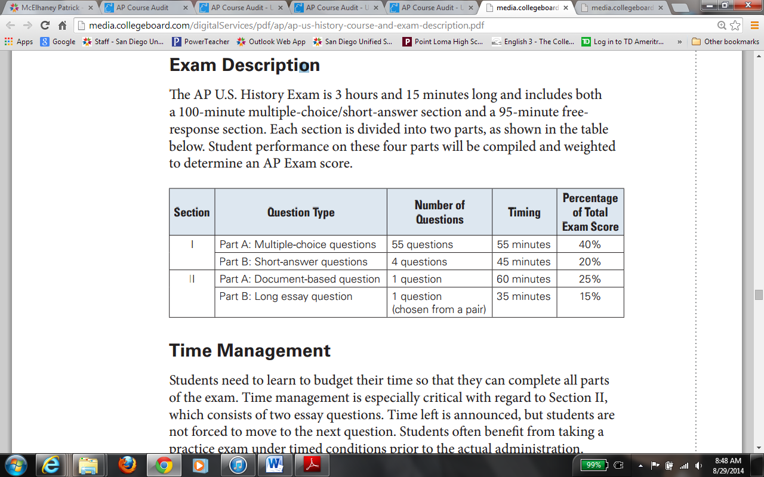

Students will be assessed on:

* Themes
* Historical Thinking Skills
* All eras of US History
* **No DBQ or FRQ** will focus exclusively on events prior to 1607 or after 1980
* Students will write at least one essay that examines long-term developments that span historical time periods/eras
* **Multiple choice questions** will contain sets of questions that ask students to respond to stimulus material (documents, charts, pictures…)
* **Short-answer questions**- all of the short-answer questions will require students to use historical thinking skills to respond to a primary source, a historian’s argument… each question will ask students to identify and analyze examples of historical evidence reliant to the source.
* DBQ- Document Based Question
  + State relevant thesis
  + Support thesis with relevant evidence from all or all but one of the documents
  + Incorporate analysis of each document- from one of the following-
    - Intended Audience
    - Purpose
    - Historical Context
    - Point of View
  + Support argument with historical information outside the documents
  + All of this synthesized into a persuasive essay